Mistakes pic 1

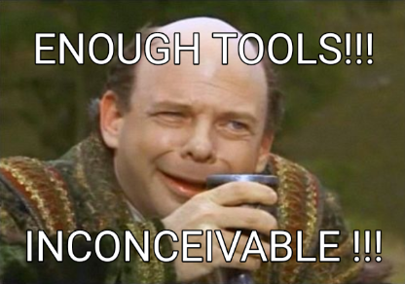

https://i.imgur.com/6TIHLwd.png

Mistakes pic 2

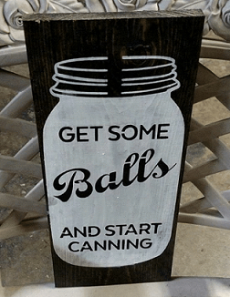

https://i.imgur.com/lKkRYGE.png

Mistakes pic 3

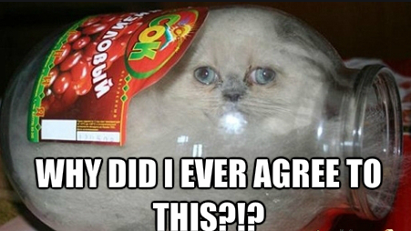

https://i.imgur.com/kSTpBSz.png